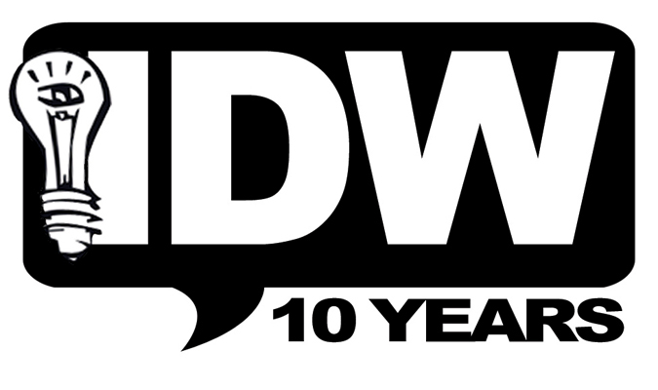
Media Contact: AnnaMaria White
AnnaMaria@IDWPublishing.com
858.270.1315, ext 121

FOR IMMEDIATE RELEASE

IDW PRESENTS WIRE HANGERS

The twisted new series is the brainchild of musician/writer/artist Alan Robert

San Diego, CA (September 28, 2009) – Life of Agony bassist/Spoiler NYC front man, Alan Robert, joins forces with IDW Publishing to release a new horror/conspiracy miniseries titled Wire Hangers. Created, written and illustrated by Robert, with covers by comic fan-favorite Nelson DeCastro (Marvel Masterpieces), Wire Hangers makes its worldwide debut in March 2010.

Robert is no stranger to comics. He studied cartooning under Walter Simonson (The Mighty Thor) at the School of Visual Arts in New York City, where he attended on scholarship and graduated with a Bachelor of Fine Arts. Best known for being the primary songwriter behind Life of Agony’s critically acclaimed River Runs Red concept album, Robert is also an accomplished artist. His illustrations and designs have appeared on merchandise, ad campaigns and Web sites for multi-platinum rock acts such as 3 Doors Down, Puddle of Mudd and Shinedown.

In Wire Hangers, which will debut with a 32-page, ad-free first issue, a series of abductions are plaguing New York, leaving no one safe. When Anna Davis, a feisty young female reporter, goes undercover to try and snag the big exclusive, she stumbles upon clues that give us a glimpse into what could be the most disturbing government conspiracy of our time. Pill-popping detectives, corrupt secret agents and a mysterious, disfigured homeless man are all inter-connected in this horrific tale of revenge and redemption.

Robert states, “I’ve wanted to tell this story for as long as I can remember. I came up with the Wire Hangers concept a few years back, when Life of Agony was on the road supporting Ozzy Osbourne. It has haunted me ever since! Whenever we were touring or in the recording studio, I would find myself sketching out characters on the back of lyric sheets and leaving myself voicemail messages with scene dialogue. By the time I presented the idea to IDW earlier this year, the story was completely fleshed out. Visually, it’s dark and gritty with tons of textures and atmosphere. The artwork really sets a tone for the series and plays an equal part in telling the story.

“I really can’t express how excited I am to finally see this idea come to life. I’ve been a huge comic book fan since I was just a kid and went to art college in the hopes of becoming a penciler one day. During my graduation year, LOA landed the record contract with Roadrunner to record River Runs Red and once it came out, I found myself touring full-time and focusing on my music career. So, for me, all these years later—to finally create my own original comic series is a dream come true. Releasing it through IDW is the icing on the cake. They’ve put out some of my favorite books, like 30 Days of Night and Welcome to Hoxford. It’s a real honor to have Wire Hangers appear alongside those titles.”

“Wire Hangers is going to hold its own up against the IDW titles that Alan has long admired,” said Chris Ryall, IDW’s Publisher/Editor-in-Chief. “When he brought me the story, both his storytelling sense and artistic skills were fully formed and ready to roll on a comic series. In much the same way Alan went from playing bass for one band to fronting another, his talents will be front and center on his comic, too.”

Wire Hangers will make its debut with a 4-issue miniseries in April 2010. Visit wirehangerscomic.com for an animated teaser featuring artwork from the series.

Visit IDWPublishing.com to learn more about the company and its top-selling books.

About Alan Robert
Alan Robert is currently recording a new Spoiler NYC album titled “Banned in 38 States” with Grammy Award winning producer Ken Lewis (Lenny Kravitz, Beastie Boys, Fall Out Boy). The album will be the sophomore release for the NY based punk-trio, following their 2007 debut, “Grease Fire in Hell’s Kitchen” (SOS Records).

Robert’s other band Life of Agony, recently celebrated their 20 year anniversary with a successful European tour where they performed in front of crowds as large as 50,000 people with Faith No More and 50 Cent. Plans to release a “20 Years Strong” DVD are in the works, featuring performance footage, interviews, backstage antics and looks at Robert’s art process for Wire Hangers. Information on Robert and his bands can be found at www.lifeofagony.com and www.spoilernyc.com.

About IDW
IDW is an award-winning publisher of comic books, graphic novels and trade paperbacks, based in San Diego, California. Renown for its diverse catalog of licensed and independent titles, IDW publishes some of the most successful and popular titles in the industry, including: Hasbro's The Transformers and G.I. JOE, Paramount's Star Trek; Fox's Angel; the BBC's Doctor Who; and television's #1 prime time series CBS' CSI: Crime Scene Investigation. IDW is also home to the Library of American Comics imprint, which publishes classic comic reprints; Yoe! Books, a partnership with Yoe! Studios; and is the print publisher for ComicMix.

IDW's original horror series, 30 Days of Night, was launched as a major motion picture in October 2007 by Sony Pictures and was the #1 film in its first week of release. More information about the company can be found at IDWPublishing.com.

